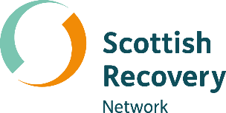

Peer-led learning and
the difference it makes

A Peer Connects Conversation Starter Kit for services and organisations


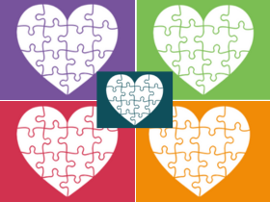

Hello!
Scottish Recovery Network collaborate with organisations and services who are passionate about peer-led learning and the positive difference it makes to people’s lives. Peer-led learning is a mutual exchange of skills, knowledge and experience. Peers learning from each other.
This conversation starter kit is for organisations and services who want to think differently about what they do to support mental health recovery. It’s the result of the fabulous ideas and insights you shared with us at one of our Peer Connects events.

The best way to find out about future events is to sign up to our newsletter or keep an eye on our website and social media channels.

How to use this Conversation Starter Kit
The conversation starter kit is a great way to frame discussions at your team meetings or team development sessions. To make it easier we have split the kit into four bitesize conversations and provided example session outlines (pages 9 - 11) for you to use and adapt to suit your needs.
- What does peer-led learning mean to you and your team?
- How to involve people with lived experience
- The peer learning space
- Embracing creativity
We know that you’re busy but even if you only have a 20-minute window there’s still lots you can cover. Pull all the conversations together in one session or separate them across shorter sessions. It’s up to you!

Support materials
North Ayrshire Wellbeing and Recovery College and Moray Wellbeing Hub are two examples of organisations who are passionate about the role of peer-led learning and the difference it makes.

This short film from North Ayrshire Wellbeing and Recovery College and this In Conversation With from Moray Wellbeing Hub provide lots of inspiration for your conversations and the peer-led theme.

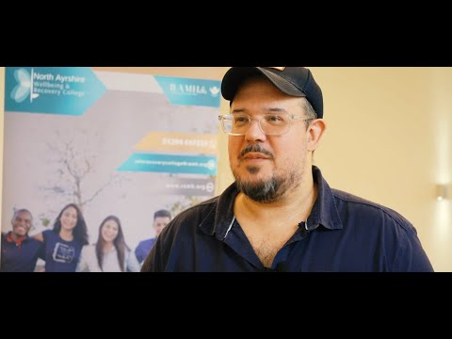


It’s been a great journey. The highlight is coming into a room and seeing people who are just coming in for the first time. Just seeing that moment where they go, ‘Oh…it’s not just me’..and the pressure just kinda lifts off them.

- John, Paid Peer Champion, North Ayrshire Wellbeing and Recovery College

Conversation 1: What does peer-led learning mean to you and your team?

- What does peer-led learning mean to you and your team?

- What would it bring to you as a service or organisation?

- How do you see it developing as an approach you use?

- Does anything else stand out from the support materials?

Conversation 2: How to involve people with lived experience
Lived experience engagement doesn’t have to be formal. In fact, some of the best ideas come from informal conversations.
Our Run Your Own Recovery Conversation Café Toolkit supports you to engage with people in a meaningful way to find out what is important to them.
VOX Scotland’s Making Co-Production Work is another tool that supports mental health professionals and service providers to implement co-productive practice.

Think about how you will involve people with lived experience at all stages of the planning, development and delivery of your peer-led learning activities.

- What steps do you need to take to ensure opportunities are peer-led?

- What opportunities can you offer for people to increase their knowledge and develop new skills? (think about what you currently deliver or would like to deliver).

Conversation 3: The peer learning space
Peers can create a unique learning space.

• What do peers contribute to learning space?

• What role do you play as an organisation or service in creating the conditions for peer learning spaces?

• What steps do you need to take to create this peer learning space?

Conversation 4: Embracing creativity
Creativity encourages learning and recovery by giving people space to discover themselves. Being creative in your approach is about being bold and doing things differently.

- What might this look like for you and your team?

- Is there anything you are doing that you could adapt or change to be more creative in your approach?

- What existing creative skills can you to draw on?

- Are there partner organisations you could work with?

Turning conversations into action!
Through your team conversations you have explored some of the different elements involved in taking a peer-led approach to learning. If you have identified opportunities for your service / organisation, what key steps do you need to take as a team to make these changes?
It might be useful to create a timetable of actions and to check in regularly on progress.
Taking action examples:
- Finding out the skills our members / people we engage with already have.

- Identify and create opportunities for people who take part in - insert activity / group - to be involved in planning and delivery.

- Bring facilitators and participants together for a conversation to shape what this will look like.

Get in touch
This Conversation Starter Kit is also available as a flipbook online where you can also download as a PDF. If you require information in a different format please contact us.

- 0300 323 9956 ContactScotlandBSL
- info@scottishrecovery.net | www.scottishrecovery.net






#PeerSupportScot


Example session plans

20-minute conversation session

Before session
Ask your team to watch the North Ayrshire Wellbeing and Recovery College film and read the ‘In Conversation With’ Moray Wellbeing Hub document before you meet.

One person from the team should take on a host / facilitator role for this session.

First 5 minutes
Connect up – the group may already know each other but it’s important to for everyone to feel connected ahead of the discussions. A connecting exercise we like to use is ‘What is one thing that made you smile recently?’

Next 15 minutes
As a group work through the three questions in conversation 1. Allow for an open discussion. Take a note of key points and actions.

After the session
To build on this conversation arrange a time(s) to come together to have conversations 2, 3 & 4 either as 20-minute sessions or longer depending on how many of the conversations you explore each time you meet.

1 hour conversation session

Before session
One person to take on a host / facilitator role.
Have the North Ayrshire Wellbeing and Recovery College film set up and visible to everyone participating in the meeting. Make sure everyone has a copy of the ‘In Conversation With’ Moray Wellbeing Hub document.

First 5 minutes
Connect up – the group may already know each other but it’s important to for everyone to feel connected ahead of the discussions. A connecting exercise we like to use is ‘What is one thing that you hope to get out of today’s discussions?’

Take 10 minutes to
Watch the North Ayrshire Wellbeing Recovery College film as a group and individually read the ‘In Conversation With’ Moray Wellbeing Hub document.

Now for 15 minutes
Start with conversation 1. As a group work through the three questions. Allow for an open discussion. Take a note of key points and actions.

Take another 15 minutes to
Choose one more conversation (2, 3 or 4) and work through the questions. Allow for open discussion. Take a note of key points and actions.

Take a final 15 minutes to
Choose one more conversation (2, 3 or 4) and work through the questions. Allow for open discussion. Take a note of key points and actions.

After session
To build on this conversation arrange a time to come together to have the remaining conversation.

Adapt to suit your needs
These session plans are just examples so feel free to adapt to suit the needs of your team. You could make your session 1 hour 15 minutes and do all four conversations in one session or 45 minutes and do 2 conversations at a time or even extend the time slots to give more space for reflection and ideas.

