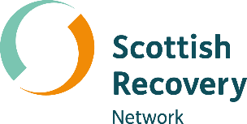

Peer support roles
in services

A Peer Connects conversation starter
kit for services and organisations




Hello!

The services and organisations we collaborate with tell us that peer support has a transformational part to play in making a positive difference in services, crisis support and our wider mental health system.
This conversation starter kit is the result of the fabulous ideas and insights you shared with us at one of our Peer Connects events. It’s for anyone interested in developing peer roles.
The best way to find out about future events is to sign up to our newsletter at scottish recovery.net/newsletter-signup, or visit our website and social media channels. These details are listed at the end of this document.

How to use this kit

From experience we know that early preparation and conversations with your team are essential if you are thinking about introducing peer support into an existing service. By doing this you can create an environment that welcomes peer support as a way to mutually complement what you’re already delivering.
We know that you’re busy but even if you only have a 20-minute window there’s still lots you can cover.
Our Let’s Develop Peer Roles toolkit which you will find at https://bit.ly/DevelopPeerRoles takes you through a process of developing the roles you want to see in your service and organisation.
This conversation starter kit is a handy way to introduce key themes before going on to use the toolkit. A chance to dip your toe in the water and test out some thinking.

Conversation starter questions

- What does peer support mean to you?
- What benefits can peer support bring to your service or organisation?
You can also refer to the ‘Benefits of developing peer support roles’ section (pages 15 and 16) of the Let’s Develop Peer Roles toolkit when you are having this conversation.
Helen’s story
In this short animation Helen tells us about her experience of being a Peer Support Worker with NHS Borders Adult Community Mental Health Service. Helen comments:
“A Peer Worker is a tangible, living, walking, breathing symbol of hope simply because of the words Lived Experience.”
Watch or listen to the animation at https://bit.ly/HelensPeerWorkerStory

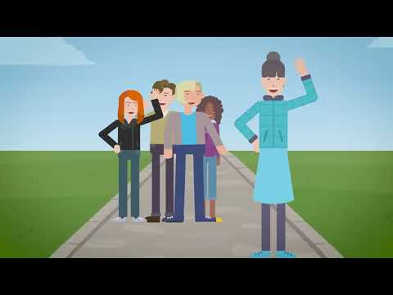

What’s next?

Use the Let’s Develop Peer Roles toolkit to start developing paid and / or volunteer roles in your service or organisation. Need a hand? Get in touch if you would like some support:
- Email info@scottishrecovery.net
- Call 0300 323 9956
- British Sign Language users can contact us using Contact Scotland BSL
There are loads more peer support resources on our website scottishrecovery.net, or why not join the conversation on social media:
- Twitter.com/ScotRecoveryNet
- Facebook.com/ScottishRecoveryNetwork
#PeerSupportScot
A Flipbook version of this document is available on our website. Or via this link https://bit.ly/PeerSupportRolesServices

